Ex.No.1 Downloading and Installing Hadoop: Understanding different Hadoop modes, Startup Scripts, Configuration files.
- Downloading and installing Java Packages
Jdk-8u411-windows x 64
- Install the Java
- Click on Next -> C:/Program Files\Java\jdk-1.8\ -> Next
- Click “Change” to install java to a different folder
  - Change -> This PC -> Local Disk C -> Create the New Folder name as Java -> Select Java => C:\Java
  - Click on Next. Jdk has been successfully installed.
- Go to the Local disk C drive and delete the Java Folder that has been created.
- Go to the Local disk C -> Program Files -> Copy the JAVA folder -> Paste it in the C drive
- To set the environment path variable: JAVA_HOME
C:\Java\jdk-1.8\bin -> Copy this path
- Open and edit the environment variable
- User Variable -> New -> JAVA_HOME -> Paste the path as C:\Java\jdk-1.8\bin
- System Variable -> Select the path -> Paste the path as C:\Java\jdk-1.8\bin
- Click Ok
- Download and install the Hadoop 2.8.0
Hadoop 2.8.0 tar.gz -> Download
Install Hadoop 2.8.0 at Local disk C
- To set the environment path variable: HADOOP_HOME
C:\hadoop\bin – Copy the path
- Open and edit the environment variable
- User Variable -> New -> HADOOP_HOME -> Paste the path as C:\hadoop\bin
- System Variable -> Select the path -> Paste the path as C:\hadoop\bin
- System Variable -> Select the path -> Paste the new path as C:\hadoop\sbin
- System Variable -> Select the path -> Paste the new path as C:\hadoop
- Click Ok
- Check the java is installed or not
- Open the command Prompt:
C:\Users\HP>java -version
Output:
java version "1.8.0_461"
Java(TM) SE Runtime Environment (build 1.8.0_461-b11)
Java HotSpot(TM) 64-Bit Server VM (build 25.461-b11, mixed mode)
- Open the command Prompt:
C:\Users\HP>javac -version
Output:
javac 1.8.0_461
- Check the hadoop is installed or not
- Open the command Prompt:
C:\Users\HP>hadoop
Output:
C:\Users\HP>hadoop
Usage: hadoop C:\Users\HP>hadoop
Usage: hadoop [--config confdir] [--loglevel loglevel] COMMAND
where COMMAND is one of:
fs run a generic filesystem user client
version print the version
jar <jar> run a jar file
note: please use "yarn jar" to launch
YARN applications, not this command.
checknative [-a|-h] check native hadoop and compression libraries availability
distcp <srcurl> <desturl> copy file or directories recursively
archive -archiveName NAME -p <parent path> <src>* <dest> create a hadoop archive
classpath prints the class path needed to get the
Hadoop jar and the required libraries
credential interact with credential providers
key manage keys via the KeyProvider
daemonlog get/set the log level for each daemon
or
CLASSNAME run the class named CLASSNAME

Most commands print help when invoked w/o parameters. [--config confdir] [--loglevel loglevel] COMMAND
where COMMAND is one of:
fs run a generic filesystem user client
version print the version
jar <jar> run a jar file
note: please use "yarn jar" to launch
YARN applications, not this command.
checknative [-a|-h] check native hadoop and compression libraries availability
distcp <srcurl> <desturl> copy file or directories recursively
archive -archiveName NAME -p <parent path> <src>* <dest> create a hadoop archive
classpath prints the class path needed to get the
Hadoop jar and the required libraries
credential interact with credential providers
key manage keys via the KeyProvider
daemonlog get/set the log level for each daemon
or
CLASSNAME run the class named CLASSNAME

Most commands print help when invoked w/o parameters.

- C:\Users\HP>hadoop version
- Hadoop 2.8.0
- Subversion https://git-wip-us.apache.org/repos/asf/hadoop.git -r 91f2b7a13d1e97be65db92ddabc627cc29ac0009
- Compiled by jdu on 2017-03-17T04:12Z
- Compiled with protoc 2.5.0
- From source with checksum 60125541c2b3e266cbf3becc5bda666
- This command was run using /C:/MY_APPS/JAVA/hadoop-2.8.0/share/hadoop/common/hadoop-common-2.8.0.jar

Hadoop Configuration
- Edit file C:/Hadoop-2.8.0/etc/hadoop/core-site.xml, paste below xml paragraph and save this file.
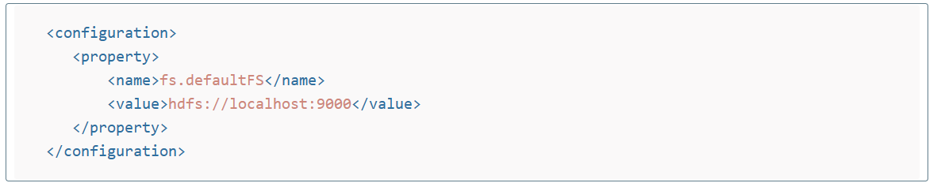
- Rename “mapred-site.xml.template” to “mapred-site.xml” and edit this file C:/Hadoop-2.8.0/etc/hadoop/mapred-site.xml, paste below xml paragraph and save this file.
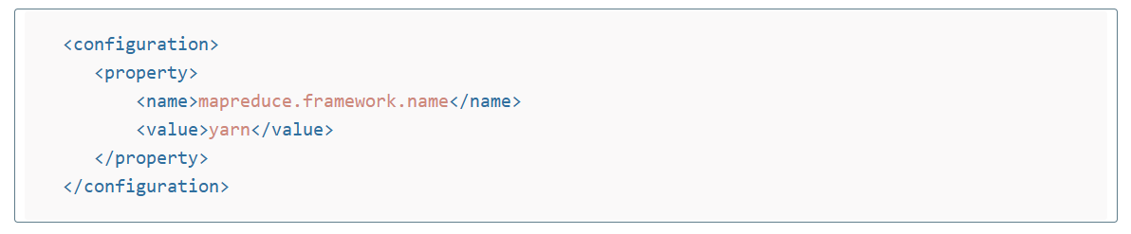
- Create folder “data” under “C:\Hadoop-2.8.0”
- Create folder “datanode” under “C:\Hadoop-2.8.0\data”
- Create folder “namenode” under “C:\Hadoop-2.8.0\data”
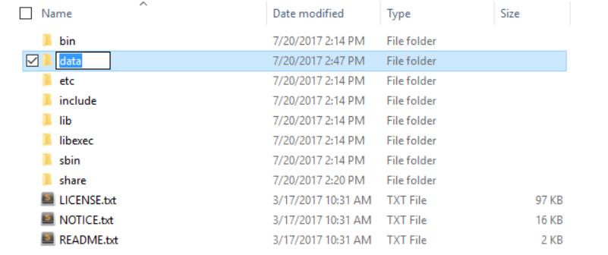
- Edit file C:\Hadoop-2.8.0/etc/hadoop/hdfs-site.xml, paste below xml paragraph and save this file.

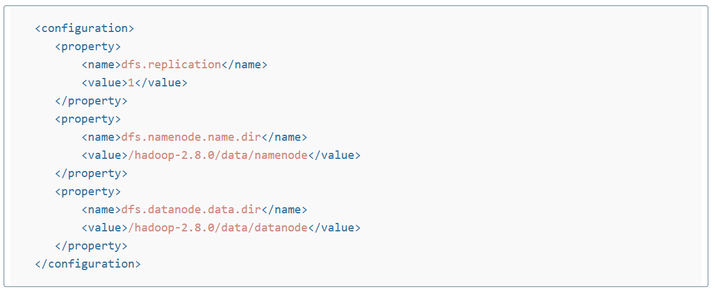
- Edit file C:/Hadoop-2.8.0/etc/hadoop/yarn-site.xml, paste below xml paragraph and save this file.
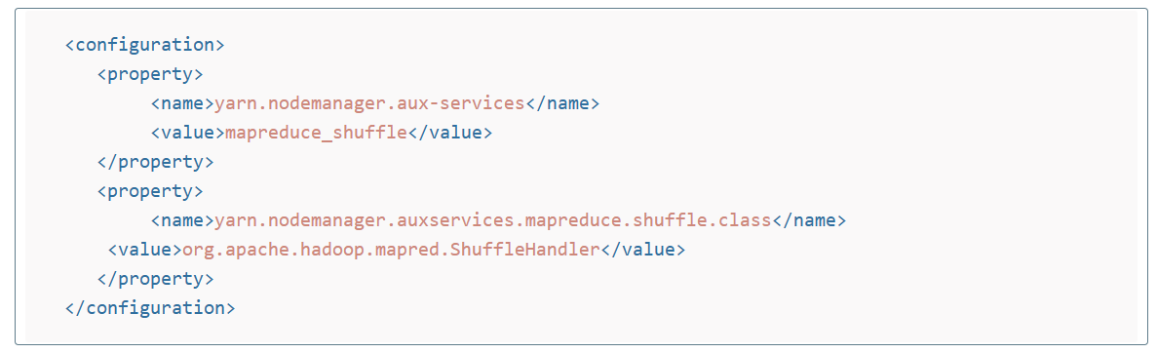
- Edit file C:/Hadoop-2.8.0/etc/hadoop/hadoop-env.cmd by closing the command line “JAVA_HOME=%JAVA_HOME%” instead of set “JAVA_HOME=C:\Java” (On C:\java this is path to file jdk.18.0)
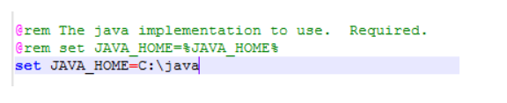
- Download the Hadoop Configuration File
- Copy the bin from the Hadoop configuration file
- Delete the bin folder from the C:\Hadoop\bin
- Paste the copied bin folder from the Hadoop configuration file in the location, C:\Hadoop\bin.
- Open the command Prompt
hdfs namenode -format

After generating the formatted data, it will ask Re-format filesystem in Storage Directory C:\hadoop-2.8.0\data\namenode ? (Y or N)

Press Y and enter

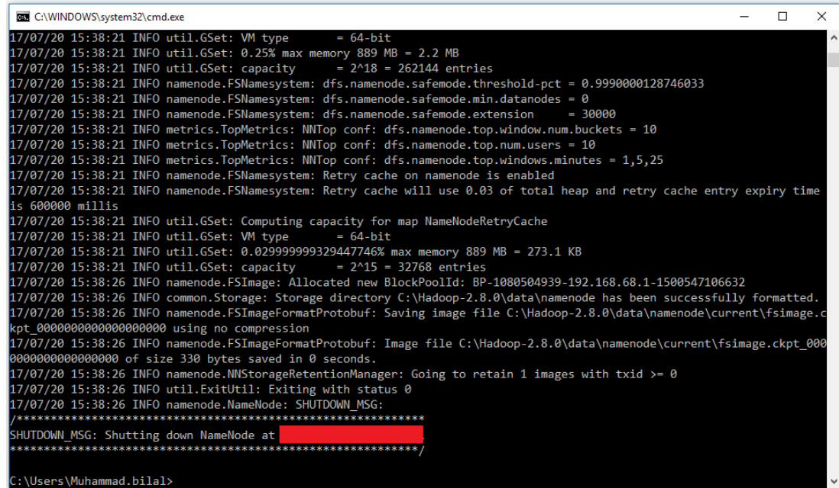

- Open the Command Prompt:
C:\Users\HP>cd “C:\hadoop-2.8.0\sbin”
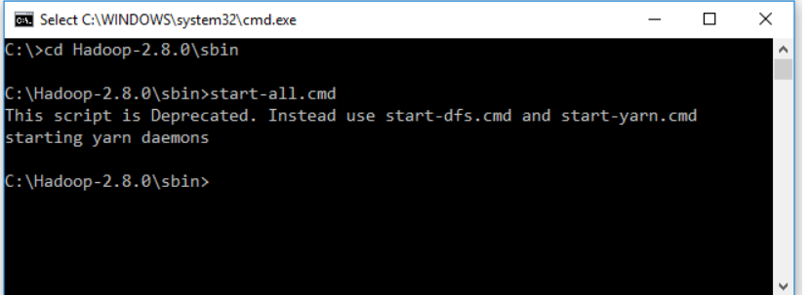

- It will move on to the directory
C:\hadoop-2.8.0\sbin> start-all.cmd

It will start running the
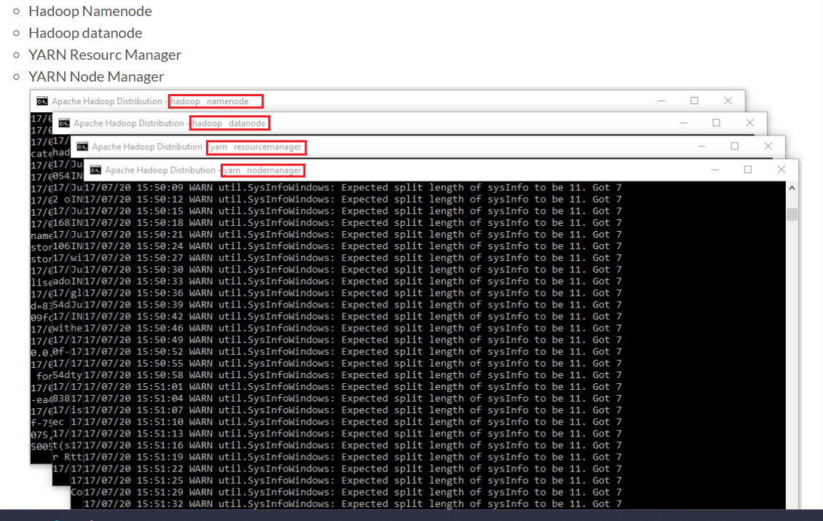

- Open: http://localhost:8088
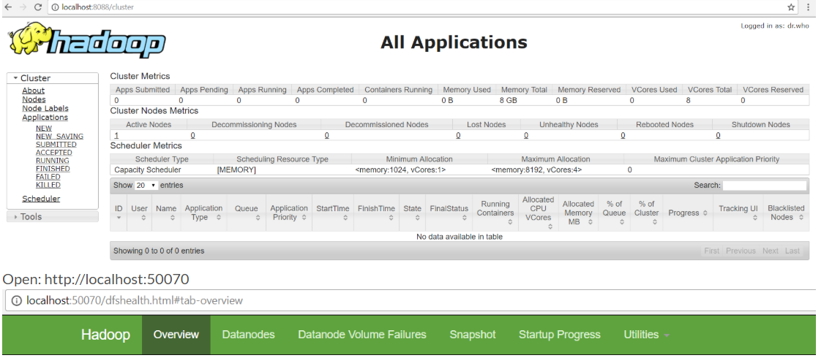

- Open: http://localhost:50070
